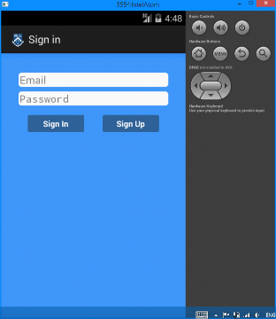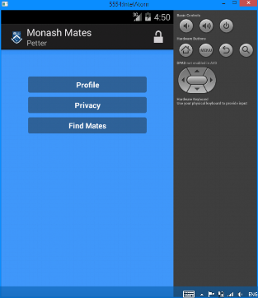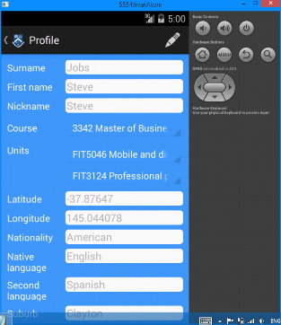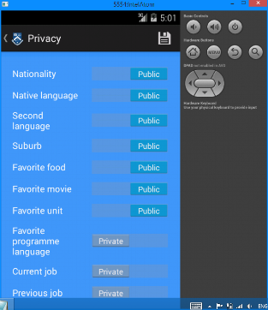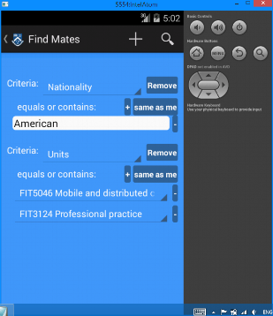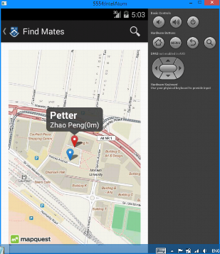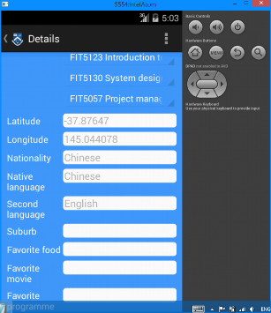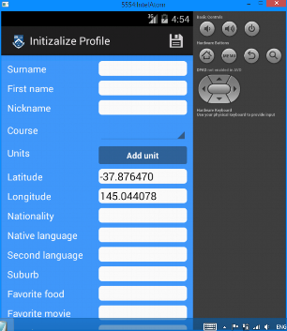

Sign up

Sign in

Logout

Complete

Home

Find Mates

Search

Home

Second level search

Home

Profile

Privacy

Tap

Back

**Legend**

* Save/Update to server
* Logout  Search
* Add criteria  Set default search values as same as current user

 Add target values  Remove target values

**Search criterion setting instruction**

1. When click ‘Find mates’ button, app generates a blank criteria automatically
2. User can select different criteria attribute by selecting from the dropdown list 
3. When user can select criteria attribute, app generates add current user attribute values as default. By this, user can search for some mates who have common attributes with himself/herself. User can also change current search target values to his/her own values by clicking ‘’ button
4. User can add multiple target values by click ‘’ button under criteria which enables user to find mates having different values. For examples, user can search mates who is from ‘Australian’ or ‘American’, or who is studying at least one of the specified units
5. User can click the ‘’ button on the action bar to add new search criterions. This enables user to search mates based on multiple criterion, like course, unit, nationality and hoppy etc.
6. After setting criterion, user clicks ‘’ button on action bar to send request to find required mates. The search operation will considerate user profile privacy setting. Only public attributes can be evaluated as matched.
7. The results are presented in map view with markers. Different color markers indicate different close level compared with current user profile: red is more closer
8. When user tap on the markers, a snippet view will be show beyond the marker with brief information (nick name, first name, surname and estimated distance) of the result people.
9. By clicking the snippet view, a new interface will emerge to host more detailed profile of the result people. However, only public attribute value can be shown.
10. User can make a second level query from current results by click the ‘’ button again on the action bar. By checking the checkbox on the top of criterion setting (search from current results), user can further filter current results with new added criterion.